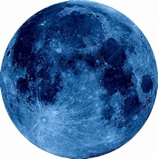**Landon Athletics**

**Moon Vault Entry Form**

__________________________________________________________________________________________

Name (Print) Phone

Address

City, State, Zip

_______________ Circle One: Masters College High School Younger

Age

Club Affiliation:________________________________________________ Gender:_____________________

Best Height in Competition:_________________________

Vaulter’s Accomplishments (meets won, all state, conference champ, records held, etc.) Use back of this form.

T-shirt size (circle one) S M L XL XXL

Medical Release

I hereby grant my child permission to compete in the Moon Vault competition. I verify that my child has had a physical exam in

the past year and is capable to participate in the activities related to the competition. I agree to indemnify, hold harmless and

defend Jerry A. Sessions. Maple Valley High School and/or their employees from any liability for injury to my child, as well as

any injury caused by my child. I also hereby grant permission to Landon Athletics to use any photography and videotape of

myself and/or child related to Moon Vault activities for advertising or educational video materials.

Competitor’s Signature

Parent’s Signature (if under 18)

Sanctioned by USATF

Entry Fee: $50

Make checks payable to: Landon Athletics